Extended Process: Inclusion of Genomic Testing (Haematology Oncology Diagnostics)

Existing As-Is Process (Summary Context)
The current process covers blood test ordering, specimen collection, laboratory analysis, reporting, communication of results, and clinical action by the Primary Treatment Centre (PTC)
Test Orders and Results-v11-202…
. Genomic testing introduces additional complexity due to specialist laboratories, longer turnaround times, data volume, interpretation requirements, and consent considerations.

Extended Process Including Genomic Testing

1. Test Request Initiation
- PTC identifies the need for genomic testing (e.g. somatic mutation analysis, cytogenetics, NGS panels, minimal residual disease testing) as part of haematology oncology diagnosis, risk stratification, or treatment planning.
- Genomic test request may be initiated:
  - At diagnosis
  - At relapse
  - During treatment response monitoring

2. Consent and Clinical Information Capture
- Explicit patient/guardian consent for genomic testing is confirmed and recorded (where required).
- Additional clinical context is documented to support interpretation, including:
  - Diagnosis and disease phase
  - Prior therapies
  - Relevant phenotypic findings
  - Family history (if applicable)

3. Sample Collection
- Sample type may include:
  - Peripheral blood
  - Bone marrow aspirate
  - Tissue biopsy
- Sample collected by Community Nurse, POSCU, or hospital-based clinical team.
- Specimen details recorded, including:
  - Sample type and volume
  - Collection time
  - Handling and storage requirements specific to genomic assays

4. Genomic Laboratory Order Creation
- A genomic laboratory order is created and sent to the designated genomic or specialist haematology oncology laboratory.
- Order includes:
  - Requested genomic assay(s)
  - Clinical indication
  - Urgency (routine vs urgent)
  - Linked phenotypic laboratory results (if available)

5. Sample Transport and Accessioning
- Specimen is transported according to genomic testing requirements.
- Receiving laboratory performs:
  - Sample accessioning
  - Quality and suitability checks (e.g. DNA/RNA integrity, tumour content)

6. Genomic Testing and Analysis
- Laboratory performs genomic testing (e.g. sequencing, cytogenetic analysis, bioinformatics processing).
- Results undergo:
  - Technical validation
  - Clinical interpretation by qualified molecular pathologists or scientists

7. Genomic Results Reporting
- Laboratory produces a genomic diagnostic report, which may include:
  - Identified variants or abnormalities
  - Clinical significance and classification
  - Diagnostic, prognostic, or therapeutic implications
  - Limitations of testing
- Report is issued electronically where possible.

8. Distribution of Genomic Results
- Genomic report is sent to:
  - PTC
  - POSCU or Community Nurse (if involved in shared care)
- Where systems are not interoperable, results may be supplemented via secure messaging or agreed alternative formats.

9. Communication and Acknowledgement
- POSCU or Community Nurse notifies PTC that genomic results have been sent and confirms receipt (mirroring the existing blood test process).
- Any issues with report readability, format, or completeness are escalated.

10. Clinical Review and Multidisciplinary Interpretation
- PTC reviews genomic results, often within a:
  - Multidisciplinary Team (MDT)
  - Molecular Tumour Board (if applicable)
- Genomic findings are interpreted alongside existing laboratory and clinical data.

11. Clinical Decision Making
- PTC may:
  - Confirm or refine diagnosis
  - Adjust risk stratification
  - Amend treatment regimen (e.g. targeted therapy eligibility)
  - Request additional genomic or phenotypic tests

12. Patient Recall and Follow-Up
- If genomic findings necessitate action:
  - Patient may be recalled for additional testing or treatment changes.
- Any prescription or care plan changes are communicated to POSCU.

13. Ongoing Data Use and Re-analysis (Where Applicable)
- Genomic data may be:
  - Re-interpreted as knowledge evolves
  - Referenced for future treatment decisions
- PTC may request amended reports if variant classification changes.

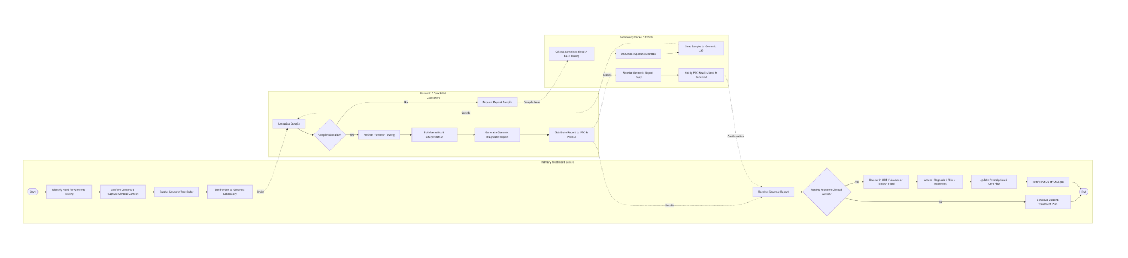

Annex A Mermaid Diagram Source

flowchart LR

%% ======================
%% PTC LANE
%% ======================
subgraph PTC[Primary Treatment Centre]
A([Start]) --> B[Identify Need for Genomic Testing]
B --> C[Confirm Consent & Capture Clinical Context]
C --> D[Create Genomic Test Order]
D --> E[Send Order to Genomic Laboratory]
O[Receive Genomic Report]
O --> P{Results Require\nClinical Action?}
P -->|Yes| Q[Review in MDT / Molecular Tumour Board]
Q --> R[Amend Diagnosis / Risk / Treatment]
R --> S[Update Prescription & Care Plan]
S --> T[Notify POSCU of Changes]
P -->|No| U[Continue Current Treatment Plan]
U --> V([End])
T --> V
end

%% ======================
%% POSCU / COMMUNITY LANE
%% ======================
subgraph POSCU[Community Nurse / POSCU]
F["Collect Sample\n(Blood / BM / Tissue)"]
F --> G[Document Specimen Details]
G --> H[Send Sample to Genomic Lab]
X[Receive Genomic Report Copy]
X --> Y[Notify PTC Results Sent & Received]
end

%% ======================
%% LABORATORY LANE
%% ======================
subgraph LAB[Genomic / Specialist Laboratory]
I[Accession Sample]
I --> J{Sample\nSuitable?}
J -->|No| K[Request Repeat Sample]
J -->|Yes| L[Perform Genomic Testing]
L --> M[Bioinformatics & Interpretation]
M --> N[Generate Genomic Diagnostic Report]
N --> W[Distribute Report to PTC & POSCU]
end

%% ======================
%% MESSAGE FLOWS
%% ======================
E -. Order .-> I
H -. Sample .-> I
K -. Sample Issue .-> F
W -. Results .-> O
W -. Results .-> X
Y -. Confirmation .-> O

